Wireless light sensor
user's Guide
Ethernet/WiFi/GPRS/4G/NBIoT/Lora
Ver1.0

Chapter One Product Introduction

1.1 Product overview
The wireless light sensor is a sensor that uses a wireless network for transmission. It does not need a special communication line, but can rely on the ubiquitous mobile phone signal network, which is very suitable for outdoor installation and monitoring. The product has excellent waterproof type and can adapt to long-term field work.
This device supports a variety of wireless working methods, including traditional GPRS, Ethernet, WIFI and 4G methods, as well as low power consumption methods such as the new Lora method and NB-IOT method. It supports DC power supply from mains, and also supports battery power supply for the connection between Lora and NB.
This device measures the light data in real time and uses wireless network for transmission. The network transmission of this product adopts a stable and reliable operator network, mature technology and stable transmission, strong signal and wide coverage. At the same time, the device supports regular data collection and active upload to the server platform.

1.2 Sensor probe parameters
parameter | Technical index
Measuring range | 0~65535/0~20Ten thousand
Measurement resolution | 1Lux
measurement accuracy | ±5%reading
Long-term stability | ≤5%/year

1.3 Equipment and communication parameter

1.3.1 GRPS Version product parameter
Parameter name | Parameter content
DC power supply | 12V-24V DC
Product power consumption | <0.4W
Transmission interface | GPRS Wireless signal transmission
Frequency band system | GSM
Operations Support | China Mobile, China Uni com 2G signal

1.3.2 4GVersion product parameter
Parameter name | Parameter content
DC power supply | 12V-24V DC
Product power consumption | <0.4W
Transmission interface | 4GWireless signal transmission
Frequency band system | FDD-LTE、TDD-LTD、TD-SCDMA、UMTS、EV-DO、CDMA、GSM
Operations Support | China Mobile, China Unicom, China Telecom's 4G、3G、2GNetcom

1.3.3 NB-Iot Version product parameter
Parameter name | Parameter content
Power supply | Battery powered/DC power supply（12-24V DC）
Battery Life | ≥1 year (higher can be customized by default)
Transmission interface | NB-Iot interface
Frequency band system | NB-Iot/2G
Operations Support | China Mobile, China Uni com, China Tele com NB-Iot

1.3.4 Lora Version product parameter
Parameter name | Parameter content
Power supply | Battery powered/DC power supply（12-24V DC）
Battery Life | ≥1 year (higher can be customized by default)
Working frequency | 433/470/868/915MHzFrequency band
Transmission distance | 800 meters (default) ~ 4500 meters (theoretical limit)
Signal protocol | Lora-Wan Or private agreement

1.3.4 WIFI Version product parameter
Parameter name | Parameter content
DC power supply | 12V-24V DC
Maximum power consumption | 0.6W
Transmission interface | WIFI type
Wifi Frequency band | 2.4G
DNSDynamic analysis | stand by

1.3.5 Ethernet Version product parameter
parametername | parametercontent
DC power supply | 12V-24V DC
POE powered by | 48V standard POE power supply (optional)
Transmission interface | RJ45 10M/100M adaptive
letter of agreement | Proactively report/TCP modbus
DNSDynamic analysis | stand by

Chapter TWO Hardware connection

2.1 Inspection before equipment installation
Please check the equipment list before installing the equipment:
name | Quantity
High precision sensor | 1 set
antenna | 1（4G/NB/LoRa）Built-in
 | 1（GPRS/WIFI）External
Battery (battery version) | 1 piece（Built-in）
12V waterproof power supply (power supply version) | 1 set（Optional）
SIM IoT Card | 1 piece（Optional）
Lora gateway | 1 set（Optional）
Warranty card/certificate | 1 serving

2.2 Product appearance size
The following is the external dimensions of the sensor. The sensor can be installed reasonably according to the size and structure, as shown in the figure:
（1）NB-IOT/LoRa Battery powered version
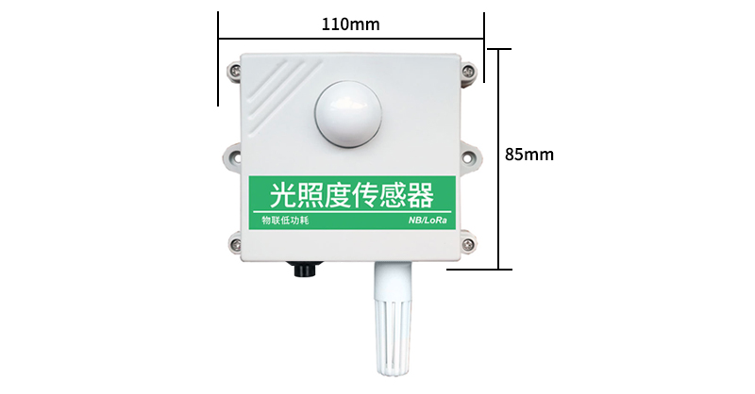

（2）4Gversion
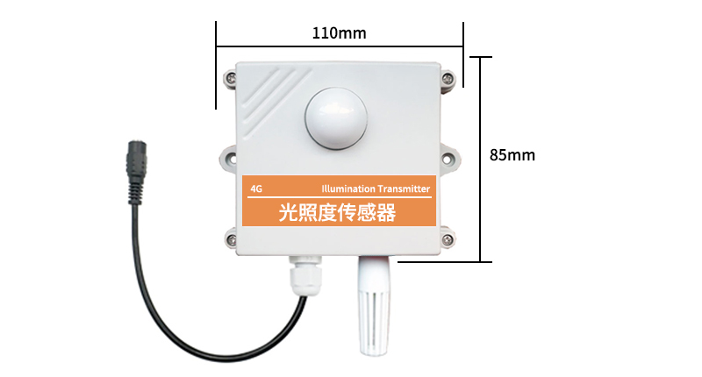
（3）GPRS version
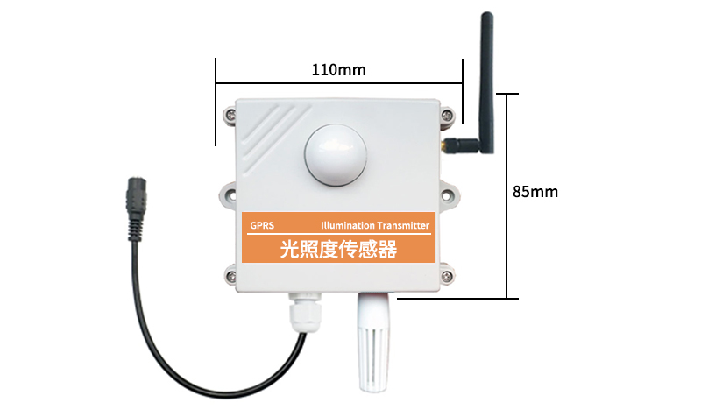
- Power over Ethernet version
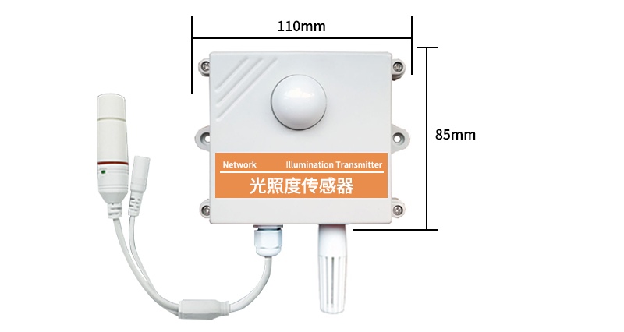
- 电Ethernet POE power supply version
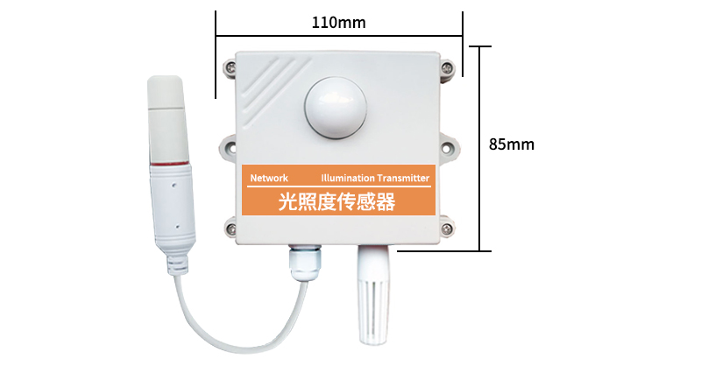

2.3 SIM card installation
The device is not equipped with a SIM card by default. Users need to install the SIM card by themselves before the device can be used. When installing the SIM card, please unscrew the four corners of the device. When you see the SIM card slot, push the SIM card into the card in the specified direction. Slot is fine. After installing the SIM card, close the front cover and tighten the screws.
Note: 2G/4G/NBIot devices and LoRa Guanqiao Cloud Box require a SIM card.

2.4 Equipment interface and installation
The product will choose to use Built-in antenna or External antenna according to the needs. When using Built-in antenna, the antenna is installed inside the shell, and the customer can use it without powering on. If an external antenna is used, the antenna and the device are separated during transportation. Yes, please screw the antenna to the device for installation.
When the device is a DC power supply, the device extends a 10cm power cord and uses a round power interface, as shown in the figure below. If the device is Battery powered, there will be no power cord, just press the button when using it.

The networked sensor adopts wall-mounted installation. The installation holes are located in the middle of both sides of the device. The installation hole diameter is less than 4mm and the hole distance is 105mm. It can be installed with 3mm self-tapping screws, as shown in the figure below.

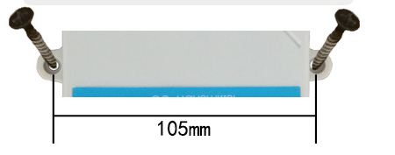

2.5 Installation matters
The installation location needs to pay attention to the following:
1. The transmitter should be placed as vertically as possible to ensure that the sensor is below the transmitter when installing on the wall (the font on the transmitter is in the positive direction);
2. The installation height is the human sitting height or the environmental area where measurement is mainly required.
At the same time, please pay attention to the following precautions:
1. Avoid installing in areas that are easy to transfer heat and will directly cause a temperature difference with the area to be measured, otherwise it will cause inaccurate light measurement.
2. Install in an area with a stable environment, avoid direct sunlight, stay away from windows, air conditioning, heating and other equipment, and avoid directly facing windows and doors.
3. Keep away from high-power interference equipment as much as possible to avoid signal influence, such as inverters/motors.

Chapter Three WIFI version configuration tool
In the wifi environment, we provide a set of configuration tools for the sensor software, which can easily configure the device using the network environment.

3.1 Basic use of configuration tools
First of all, you need to unzip our sensor to a separate folder. Don’t miss any files. Please make sure that the .Netversion of your computer is 2.0 and above, and all versions above Win7SP1version have .Net2.0version pre-installed, XP or earlier Win7 please Install .Net2.0.
As shown in the figure below, the software interface is divided into the following parts, the left is the device search and operation information display area, and the middle is the configuration area, which can perform basic device configuration, sensor debugging and firmware upgrade.
When in use, click to search for devices, and all online devices will be displayed in the device list at this time, and then double-click the device you need to access in the device list to get the current basic configuration of the device. Please note that before each step, you must first search for the device and double-click the device, as shown in the figure below.

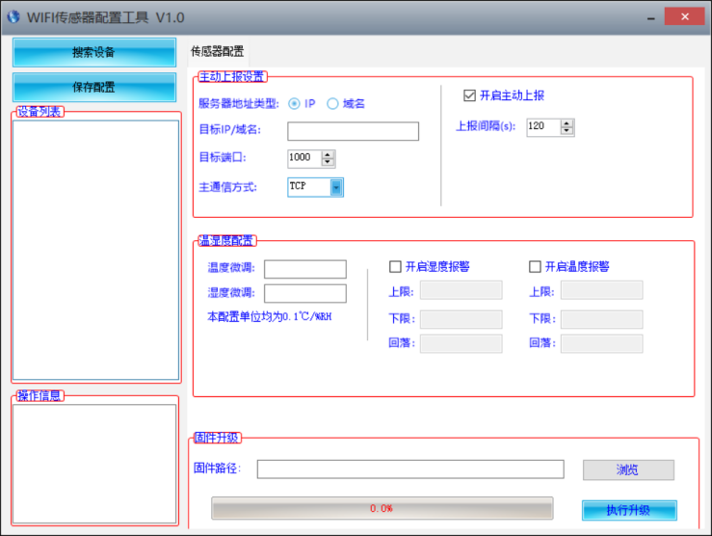

3.2 Sensor network configuration
The basic settings of the equipment mainly include the following aspects:
Proactively report settings
Server address type | You can choose to upload to a designated IP or a designated domain name.。
Target IP/domain name | The specified IP or domain name to be uploaded to. The length of the domain name cannot exceed 32 English.
The spDestination port | The designated port to be uploaded to。
Main communication mode | TCP protocol or UDP protocol used for active upload.

Chapter Four Ethernet version configuration tool
Our company provides the supporting "Ethernet Software Configuration and Debugging Tool", which can conveniently use the computer to set up the Ethernet sensor, modify the network information, and read the sensor value.

4.1 Basic software usage and device search
First of all, you need to unzip our sensor to a separate folder. Don’t miss the files. Please make sure that the .Netversion of your computer is 2.0 and above, and the ones above Win7SP1version are pre-installed with .Net2.0version, XP or earlier Win7 please Install .Net2.0.
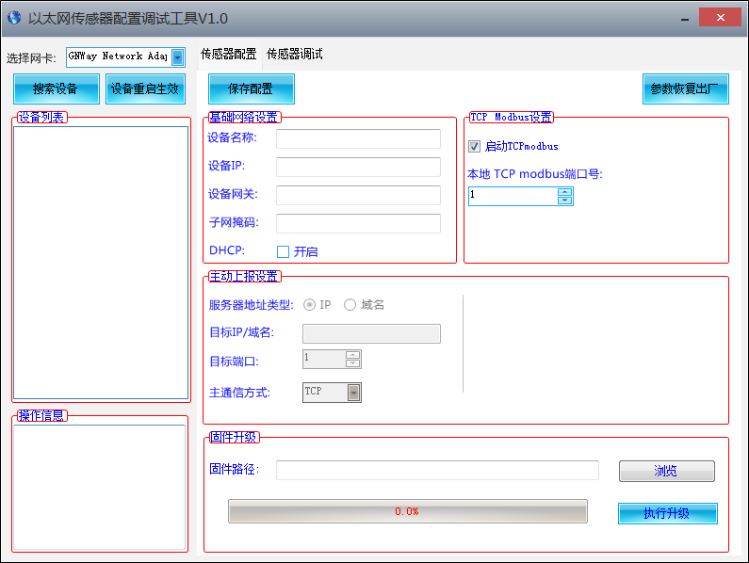
The software interface is divided into the following parts, as shown in the figure, the left side is the device search and operation information display area, and the middle is the configuration area, which can carry out basic device configuration, sensor debugging and firmware upgrade.
Please note that you should first select the correct network card when using it, especially when your computer has a wired network card and a wireless network card. Then click Search Device, all online devices will be displayed in the device list, and then double-click the device you need to access in the device list to get the current basic configuration of the device. Please note that you must first search for the device and double-click the device before each step, as shown in the figure below.
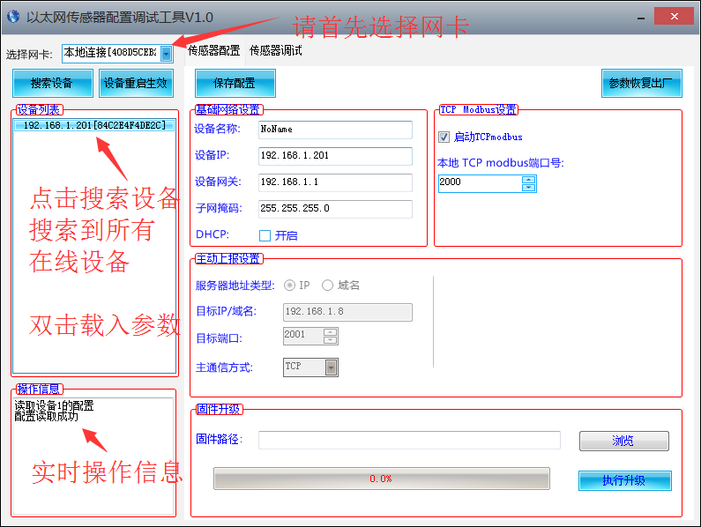
You can modify the specified parameter. After modifying the parameter, click

4.1 Sensor network configuration
The basic settings of the equipment mainly include the following aspects:
Basic network settings
Equipment name | Customers use to mark their own equipment name, modify it by themselves, and the length is not more than 10 Chinese characters or 20 English.
Equipment IP | The static IP of the Ethernet sensor itself, this IP is used when DHCP is not checked.
Equipment Gateway | The gateway of the Ethernet sensor itself, use this gateway when DHCP is not checked.
Subnet mask | The Subnet mask of the Ethernet sensor itself, use this Subnet mask when DHCP is not checked.
DHCP | Automatically search for IP, it will automatically obtain IP, Gateway, Subnet mask according to the router in your network.  If DHCP is not enabled in the router, a static IP will be used after 1 minute.
TCP modbus Set up
start up TCP modbs | After checking this option, equipment works in TCP modbus slave mode. TCP modbus and active upload can only choose one
Local TCP  modbus port | The listening TCP port number.
Proactively report settings
Server address type | You can choose to upload to a designated IP or a designated domain name.。
Target IP/domain name | The specified IP or domain name to be uploaded to. The length of the domain name cannot exceed 14 English.
The Destination port | The designated port to be uploaded to。
Main communication mode | TCP protocol or UDP protocol used for active upload.

4.2 Sensor parameter Set up
Some parameters can be set up on the sensor debugging page. Note that when setting up these parameters, the equipment must work in TCP modbus mode, and cannot work in active upload mode.
TCP modbus Configuration Set up
TCP modbusSlave address | The slave address of TCPmodbus can be set up, the range is 0-253, where 254 is the broadcast address
agreement type | You can choose the active upload protocol type, 0 means not uploading actively, 1 means uploading actively using the system default protocol, 2 means uploading actively using other protocols.
Reporting interval | The reporting interval of active upload, the unit is 1s, and the range is 1-65535 seconds.

4.3 Switch between active upload and TCP modbus mode
The system works in TCP modbus mode by default. If you need to switch to the active upload mode, please follow the steps below. Pay attention to the sequence of steps not to be disordered, otherwise the configuration will fail.
①Set up the reporting protocol on the sensor debugging page to 1, and modify the reporting interval to the interval you expect.
②On the sensor configuration page, uncheck the option to start TCPmodbus, and Set upProactively report settings to save the configuration.
If you need to switch back to TCPmodbus mode, please follow the steps below, paying attention to the sequence of steps not to be disordered, otherwise the configuration will fail.
①On the sensor configuration page, check the option to start TCPmodbus and save the configuration.
②Report the protocol as 0 on the sensor debugging page Set up.

Chapter Five Sensor connected to Jingxun Cloud

5.1Jingxun Cloud Introduction
Jingxun Cloud, a universal IoT cloud set developed by Jingxun Changtong. Based on industry solutions, it solves the problem of traditional cloud sets that focus on linking and light experience, and upgrade the front-end display effect and style on the basis of links, and integrate More than ten industry interface templates are a set of IoT systems integrating solutions, data collection, early warning release, remote control, and data analysis. Jingxun Cloud provides data recording, query, export, comparison and other functions, mainly to provide customers with one-stop joining services at the application layer.

5.2 Advantages of Jingxun Cloud
(1) Stability: High stability, the overall system availability rate is greater than 99.7%, and the database application availability rate is greater than 99.8%, and it will be maintained regularly.
(2) Ease of operation: provide friendly user management and usage
(3) Reliability: In the system design, the reliability of the system is ensured by selecting excellent products and adopting necessary technical means
(4) Compatibility: The products of other companies are in accordance with our server agreement, and the data can also be viewed in our company’s set production
(5) "Thousands of people and thousands of faces": It has privatization deployment, and provides two entrances, normal entrance and neutral entrance. After entering from the neutral entrance, the interface information that the customer sees is the information set by the customer.
(6) WeChat applet: You can check equipment status, data, equipment binding location, etc. on WeChat mobile phone.

5.3 Sensor data query
When you buy a sensor with a reporting function, you can view the data remotely through Jingxun cloud server, which is convenient and quick.
The sensor equipment establishes a connection with the Jingxun cloud server through the 4G/NB-IOT network module, and reports the data to the cloud server according to the default frequency (adjustable frequency).
You only need to log in to the server with the registered Jingxun Cloud account, and then query the equipment data by using the unique "identity ID" of each set of hosts.
At the same time, the ping set also has an alarm function. You only need to set the alarm value through the ping set. If the monitoring data exceeds the alarm value, the ping set will notify you via SMS or QQ mailbox, allowing you to monitor the data more conveniently and quickly.
Note: You can contact our after-sales staff to understand the specific functions of the flat set

